Department of Computer Science and Engineering
The University of Texas at Arlington

Super Duper TxDOT Troopers
Sliding Profiler System

Team Members:
Tim Dockins
Sare Ehmann
Robyn Johnson
Brandon Skinner
Late Updated: d MMMM yyyy 39928.7451388889 h:mm:ss am/pm
Copy Printed: d MMMM yyyy 39926.4777777778 h:mm:ss am/pm
Table of Contents
1 Product Services and Summary 1
1.1 Purpose 1
1.2 Document Overview 1
1.3 Scope & Description 2
1.4 Definitions, Acronyms, and Abbreviations 2
2 Environments 4
2.1 Development Environment 4
2.2 Operations Environment 5
2.3 Maintenance Environment 5
3 External Interface and Data Flows 6
3.1 Hardware Interfaces 6
3.2 Software Interfaces 6
3.3 High-Level Data Flow Datagram 7
3.4 Logical Data Sources and Sinks 8
4 Customer Requirements 9
4.1 Introduction 9
4.2 General 9
4.3 Platform Requirements 10
4.4 Electronics Device Requirements 11
4.5 Client Application Requirements 16
5 Localization Requirements 19
5.1 Requirements 19
6 Marketing and Sales Requirements 20
6.1 General 20
6.2 Requirements 20
7 Administrative Requirements 21
7.1 General 21
7.2 Requirements 21
8 Development Requirements 22
8.1 General 22
8.2 Requirements 22
9 Quality Assurance Requirements 24
9.1 General 24
10 Safety Requirements 26
10.1 General 26
10.2 Requirements 26
11 Standards Compliance 28
11.1 General 28
11.2 Standards 28
12 Maintenance Requirements 31
12.1 General 31
12.2 Requirements 31
13 Support Requirements 33
13.1 General 33
13.2 Requirements 33
14 Performance Requirements 34
14.1 General 34
14.2 Requirements 34
15 System Constraint Requirements 38
15.1 General 38
15.2 Requirements 38
16 Exception Conditions and Handling 40
16.1 General 40
16.2 Exceptions 40
17 Early Subsets and Implementation Priorities 42
17.1 General 42
17.2 Subsets 42
18 Foreseeable Modifications and Enhancements 43
18.1 General 43
18.2 Enhancements 43
19 Acceptance Criteria 44
19.1 General 44
19.2 Criteria 44
20 Design Guidelines 47
20.1 General 47
20.2 Guidelines 47
21 Assumptions 48
22 Sources of Information 49
23 Use Cases 50
23.1 General 50
23.2 Use Cases 50
24 Glossary of Terms 57

Product Services and Summary

Purpose
The purpose of the project is to redesign the current model of the Sliding Profiler in order to aid the end-user in the prevention of bumps when laying road pavement. This includes, but is not limited to, redefining the design to make it smaller and more efficient for use. For the remainder of the document, the Sliding Profiler refinement shall be referred to as the Product and the accompanying software shall be referred to as the Client Application.

Document Overview
This document is to provide specific requirements that the project must meet.
Chapter 1 Product Services and Summary Provides an overview of the project and this document.
Chapter 2 Environments Provides a description of each environment in which this Product will be developed, used or maintained.
Chapter 3 External Interface & Data Flows Provides the definitions of all external data items and data flows. Does not contain internal data items or data flows.
Chapter 4 Customer Requirements Requirements originated by customers.
Chapter 5 Localization Requirements Requirements to adapt the Product for specific language or cultural usage.
Chapter 6 Marketing and Sales Requirements Requirements originated or in support of Marketing and Sales
Chapter 7 Administrative Requirements Requirements imposed by the organization’s administrative procedures.
Chapter 8 Development Requirements Requirements originated by the development team.
Chapter 9 Quality Assurance Requirements Requirements originated by or in support of Quality Assurance.
Chapter 10 Safety Requirements Requirements imposed by law, regulation or common sense whose primary purpose is the assurance of Product safety.
Chapter 11 Standards Compliance A compendium of standards (ANSI, ISO, CCITT, etc.) and regulations to which the Product must conform. Conformance is stated as a requirement.
Chapter 12 Maintenance Requirements Requirements aimed at increasing maintainability.
Chapter 13 Support Requirements Requirements that are necessary for the required level of support.
Chapter 14 Performance Requirements Requirements constraining reliability, speed, etc. Includes most constraints.
Chapter 15 System Constraint Requirements Non-functional requirements that act to constrain or limit the system in some way
Chapter 16 Exception Conditions and Handling Description and handling of all known exceptions
Chapter 17 Early Subsets and Implementation Priorities
Skeleton incremental development plan
Chapter 18 Foreseeable Modifications and Enhancements
Prognostications on the future of the Product.
Chapter 19 Acceptance Criteria Details of criteria to be met for the product to be acceptable
Chapter 20 Design Guidelines Ideas, general information about design of the product.
Chapter 21 Assumptions Generally accepted information or facts relating to the product, its environment, etc.
Chapter 22 Sources of Information Sources, human and written, of information that applies to this product.
Chapter 23 Use Cases Use cases for all externals.
Chapter 24 Glossary of Terms An aggregation of each chapter’s terms.

Scope & Description
The Sliding Profiler is a product originating with Dr. Roger Walker. It is a piece of equipment used currently by, but not restricted to, the Texas Department of Transportation. The current version’s main use is to aid in the development of new roadways by ‘bump detection’. Since TxDOT workers are on a bonus/penalty system it is very important that the roadways produced are as smooth as possible. The goal of this project is to upgrade the current model to make it more user-friendly and accurate.
The current model consists of the following:
- Inclinometer
- Distance Encoder
- Heartbeat Light (to show that the program is up and running)
- Beacon Light (bump identifier)
- ON/OFF Switch
- Connections to External Power (provided by the client)
- Connections to Client PC
- Snowboard (platform)
The upgrade will feature the following:
- A smaller platform (scaled down to provide a more accurate reading)
- New client application (for calibration and data analysis)
- Upgraded circuitry (to make the shift from a micro-embedded PC to a micro-controller)

Definitions, Acronyms, and Abbreviations
- AC Alternating current, standard wall outlets have 120v AC
- ANSI American National Standards Institute
- Client Application the software component of the Product.
- Crystal Oscillator an electronic circuit that uses the mechanical resonance of
vibrating crystal of piezoelectric material to create an electrical signal with a very precise frequency
- Distance Encoder A device used to measure distance
- IEC International Electrotechnical Commission – An international standards
organization dealing with electrical, electronic, and related technologies.
- IEEE Institute of Electrical and Electronic Engineers
- Inclinometer A device used to measure angles
- Integrated Circuit (also known as IC, microcircuit, microchip, silicon chip, or chip)
A miniaturized electronic circuit (consisting mainly of semiconductor devices, as well as passive components) that has been manufactured in the surface of a thin substrate of semiconductor material
- ISO International Standards Organization
- LED Light-Emitting Diode
- Micro-Controller (also MCU or µC) A small computer on a single integrated
circuit consisting of a relatively simple CPU combined with support functions such as a crystal oscillator, timers, watchdog, serial and analog I/O etc
- Piezoelectric The ability of some materials (notably crystals and certain ceramics,
including bone) to generate an electric potential in response to applied mechanical stress
- Product The refined Sliding Profiler System.
- SDLC Software Development Life Cycle
- SDTT Super Duper TxDOT Troopers, the development team for this Product
- SRD Systems Requirements Definition, a full comprehension of
requirements of each area of the project from functionality to development to maintenance and use-cases
- TxDOT Texas Department of Transportation
- Operator Any person trained to operate the Product; in this case: employees of
the Texas Department of Transportation or those approved by the supplier, SDTT/Dr. Roger Walker
- User, Support The Support User is any person trained to configure the Product
- Technician The Technician user is any person trained to calibrate the sensors in the Product
- UTA The University of Texas at Arlington

.

Environments

Development Environment

Operating Systems Used Throughout Development
- Microsoft XP SP2
- Microsoft Vista (Business, Ultimate)

Scheduling and Tracking Software
- Microsoft Project Professional (2007)
- Microsoft Excel
- Google Groups

Image Generation Software:
- Microsoft Visio (Version 2007)

Office Productivity Software:
- Microsoft Word (2007)
- Microsoft Excel (2007)
- Microsoft PowerPoint (2007)

Source Control Software

Subversion
- SVN Client – TortoiseSVN
- SVN Server – xp-dev.com

Hardware to be used during development
- Windows compatible laptops/desktops

Operations Environment
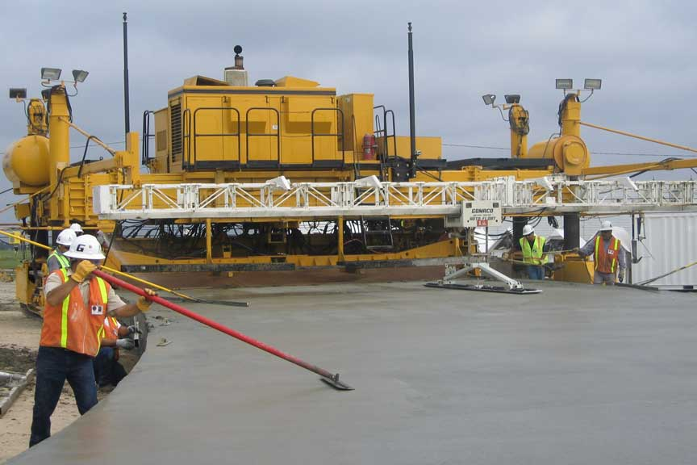
Generally, the product shall be used in an outdoor, construction job site around heavy machinery designed for laying concrete pavement for roads and highways. It is highly possible that the device will travel from its storage location to the job site in the back of a pick-up truck.
Figure 1 - Rear view of a typical paver
Positioning – This device will be attached to the rear of a concrete paver. It is intended to slide across the surface of the freshly paved concrete.
Weather Conditions – Concrete cannot be poured in all weather conditions. The best conditions are those with medium-to-low moisture (low humidity, low precipitation) with temperatures above freezing. This project assumes use of the device in Texas. Further, this device sits atop heated concrete.
The profiler will thus be likely used in an outdoor, dry bulb temperature range of 40º F during the winter to 120º F during the summer. While the operational environment may be without precipitation, it is possible that the device will be exposed to some moisture during transport or when not in use.
Debris – This device will be exposed to wet, freshly poured concrete, dust and possibly gravel particles.
Personnel – This device will be operated by personnel working behind the paver.

Maintenance Environment
The Product will be maintained by the support-user unless there is a critical error (described later in this document). If a critical error is detected, the unit must be returned to the supplier/technician for maintenance repairs.
General maintenance of the Product may occur at the job-site, at the foreman’s office or at the construction company’s local site.

External Interface and Data Flows

Hardware Interfaces
The Product shall provide a port to connect to a client PC. This port will provide connectivity to retrieve recorded data as well as configure and calibrate the Product. The Product will also have at least three ports to interface with sensors.

General Requirements
The Product shall provide the user a simple ON/OFF switch and shall start functioning without additional user input. The Product shall also provide a port used to do various tasks by the client software such as download stored data and send data to the Product to configure the Product.

User Displays and Outputs
The Product shall provide various lights used to indicate the state of the device. These lights include, but are not limited to, a power light, a heartbeat light, a bump detected light, and an error light. No graphical user interfaces will be provided on the Product.

User Input
The Product shall provide an ON/OFF switch used to control the power of the device.

Control Interface
The Product shall provide two modes of control. The first shall be a simple ON/OFF switch and the Product shall begin normal operations. The second shall be while connected to the client software via the connectivity port. In this mode the Product will allow the client software to download stored data and send configuration commands to the Product.

Software Interfaces
The client software shall provide a user friendly interface for accessing data from the Product and for sending configuration commands to the Product. The software shall also provide a mechanism for locking the configuration section to restrict untrained persons from reconfiguring the Product.

General Requirements
The Client Application will provide the means to retrieve operational data from the Electronics / Device. This data will be displayed in either list or graphical formats.
Operational data is a set of event which may be either a bump-detection event or an error event. The event data will indicate the following:
- Type of Event (Bump Detection | Error Condition)
- Distance Marker at which the event occurred
- Timestamp at which the event occurred

User Displays and Outputs
The Client Application shall display operational data to the user in either list or graphical format. This data may be provided as in the mock-up below:

User Input
The Product shall provide an ON/OFF switch used to control the power of the device.

Control Interface
The Product shall provide two modes of control. The first shall be a simple ON/OFF switch and the Product shall begin normal operations. The second shall be while connected to the client software via the connectivity port. In this mode the Product will allow the client software to download stored data and send configuration commands to the Product.

High-Level Data Flow Datagram
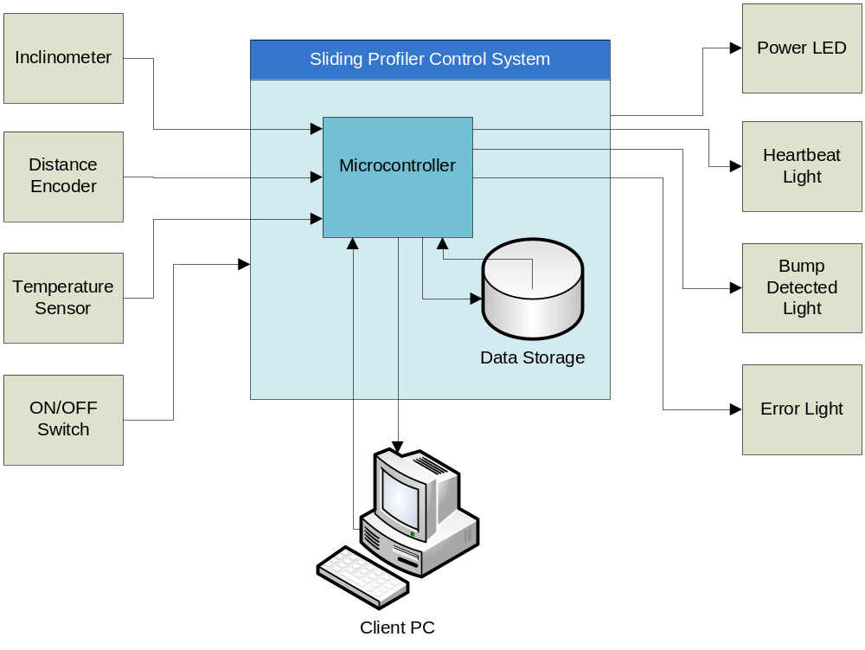

Logical Data Sources and Sinks
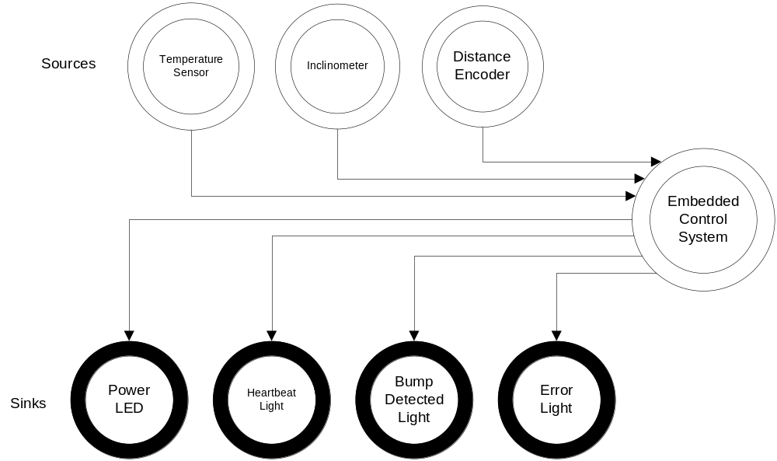

Customer Requirements

Introduction
This section covers requirements stated by the customer. It describes the functional requirements of the system. The product may be decomposed into three components; the platform, the electronics device and the client application. The General section describes states functional requirements of the overall product.

General

The Product shall visually indicate bumps using a beacon light.

Description
The system shall indicate bumps in wet concrete when pulled behind a road paver. See Figure 1 - Rear view of a typical paver for a picture of the environment. The beacon light shall be used to signal the operators of a detected bump in the pavement.

Source
This requirement was introduced by the Sponsor.

Applicable Constraints
The light must be easily noticeable in bright sunlight.

Applicable Standards
N/A

The Product shall come with a storage solution.

Description
The Product shall be stored in an easily transported, easily stored box or container.

Source
This requirement was introduced by Sare Ehmann based on comments from the Sponsor.

Applicable Constraints
- Storage must be easy to transport.
- Storage must take up minimal extra space.
- Storage must be airtight to prevent entry of moisture into the system during storage.
- Storage shall prevent handling damage.

Applicable Standards
N/A

The Electronics shall be detachable from the Platform.

Description
The electronics housing shall be easily detachable (by the operator or technician) from the platform.

Source
This requirement was introduced by the Sponsor.

Applicable Constraints
N/A

Applicable Standards
N/A

The Product shall be able to operate in a stand-alone mode.

Description
The device shall not require a PC or any external processing device to operate. It shall be able to execute its primary function; to indicate the detection of a bump in the surface of the road as defined by Error: Reference source not found.

Source
This requirement was introduced by the Sponsor.

Applicable Constraints
N/A

Applicable Standards
N/A

Platform Requirements

The Platform shall attach to a road paver.

Description
The Platform shall attach to a road paver, which will pull the Platform along the wet cement after it has been poured. Various other configurations were tested with the pilot devices and it was found that attaching to the paver provided the best results.

Source
This requirement was introduced by the Sponsor.

Applicable Constraints
- The attachment points should conform to other requirements in this document.
- The attachment process should be simple.

Applicable Standards
N/A

The Platform shall be easy to clean.

Description
In order to maintain working order, the system must be cleaned of cement residue. The Product must allow this cleaning to occur without compromising system integrity.

Source
This requirement was introduced by the SDTT team.

Applicable Constraints
N/A

Applicable Standards
N/A

Electronics Device Requirements

The Device shall detect bumps in concrete pavement when its platform is pulled across the surface.

Description
The connected platform shall be pulled across the surface of concrete as it is being paved. The primary function of this Product is to indicate bumps in the surface. To do this, a simple algorithm utilizing inclination and distance was devised by Dr. Walker. The Device shall use this or a similar algorithm.

Source
This requirement was introduced by the Sponsor and elaborated on by Tim Dockins.

Applicable Constraints
N/A

Applicable Standards
N/A

The Device shall be able to measure the travel distance of the platform.

Description
The algorithm mentioned in requirement 4.4.1 requires accurate distance measurement as the platform is slid over the surface of the concrete. Thus, the Device shall measure the travel distance of the platform. See 14 - Performance Requirements for details on the performance requirements for distance measurement.

Source
This requirement was introduced by the original system.

Applicable Constraints
N/A

Applicable Standards
N/A

The Device shall be able to measure the inclination of the platform from a calibration point.

Description
The algorithm mentioned in requirement 4.4.1 requires accurate measurement of the inclination of the platform as it is slid over the surface of the concrete. Thus, the Device shall measure inclination of the platform. See 14 - Performance Requirements for details on the performance requirements for inclination measurements.

Source
This requirement was introduced by the Sponsor and elaborated on by Tim Dockins.

Applicable Constraints
N/A

Applicable Standards
N/A

The Device shall be able to measure the internal temperature of the electronics housing.

Description
The system shall be able to measure the internal temperature of the electronics housing. This may be used to prevent operation in heat ranges beyond manufacturer’s specifications.

Source
This requirement was introduced by the Sponsor and elaborated on by Tim Dockins.

Applicable Constraints
N/A

Applicable Standards
N/A

The Device shall visually indicate when it is operating.

Description
The Device shall provide a constant visual indicator that the device is powered-on and operating. For instance, the device may provide a heartbeat indicator or a steady-on light.

Source
This requirement was introduced by the Sponsor and elaborated on by Tim Dockins.

Applicable Constraints
N/A

Applicable Standards
N/A

The Device shall visually indicate error conditions.

Description
The Device shall provide a visual indicator that the device has experienced an error condition. See 16- Exception Conditions and Handling for more detailed information.

Source
This requirement was introduced by the Sponsor and elaborated on by Tim Dockins.

Applicable Constraints
N/A

Applicable Standards
N/A

The Device shall generate operational data from the raw data of the sensors.

Description
The device shall utilize the raw data from the sensors to generate operational data. An algorithm has been provided for this purpose. Operational data is defined as an event set. Those events may be of two types: 1) bump detection and 2) error event. Any event shall note the event type, the distance marker of the event and a time-stamp. The distance marker may be the distance travelled from first use after the device was last powered on.

Source
This requirement was introduced by the Sponsor and elaborated on by Tim Dockins.

Applicable Constraints
N/A

Applicable Standards
N/A

The Device shall use an embedded microcontroller.

Description
The Product should update the current embedded PC with an embedded microcontroller.

Source
This requirement was introduced by the Sponsor.

Applicable Constraints
The embedded microcontroller shall cost less than current embedded PC.

Applicable Standards
N/A

Configuration processes shall be obscured from the end-user.

Description
The configuration of the microprocessor and calibration of sensors shall only be accessible through the client application. The operator shall not have the capability to change these settings.

Source
This requirement was introduced by the Sponsor.

Applicable Constraints
N/A

Applicable Standards
N/A.

The Device must turn on/off easily.

Description
The start-up/shut-down sequence should be initiated by a simple button press or flipped switch.

Source
This requirement was introduced by the Sponsor.

Applicable Constraints
- Start-up/shut-down processes should not take more than one minute.
- Shut-down shall not corrupt data storage.

Applicable Standards
N/A

The Device shall store operational data.

Description
The raw sensor data shall be stored during operation to a data-store on the Product platform.

Source
This requirement was introduced by the Sponsor.

Applicable Constraints
N/A

Applicable Standards
N/A

The Device shall transfer operational data to the client application in real-time.

Description
Operational data is defined as an event. That event may be of two types: 1) bump detection and 2) error event. Any event shall note the event type, the distance marker of the event and a time-stamp. The distance marker may be the distance travelled from first use after the device was last powered on.

Source
This requirement was introduced by the Sponsor and elaborated on by Tim Dockins.

Applicable Constraints
N/A

Applicable Standards
N/A

The Device shall not operate after a critical error.

Description
If a critical error is encountered, the Device shall shut down and cease to function until maintenance has been performed.

Source
This requirement was introduced by the Sponsor / SDTT team.

Applicable Constraints
N/A

Applicable Standards
N/A

The Device shall operate in high heat.

Description
The Device must operate in temperatures achieved during sustained work in an average Texas summer.

Source
This requirement was introduced by the Sponsor.

Applicable Constraints
The Product shall be able to operate continuously for 24 hours.

Applicable Standards
N/A

The Electronics housing shall be easy to clean.

Description
In order to maintain working order, the system must be cleaned of cement residue. The Product must allow this cleaning to occur without compromising system integrity.

Source
This requirement was introduced by the SDTT team.

Applicable Constraints
N/A

Applicable Standards
N/A

Client Application Requirements

The Product shall have a user-friendly client application.

Description
The client application should be easy to use and install without specialized training.

Source
This requirement was introduced by the Sponsor.

Applicable Constraints
N/A

Applicable Standards
N/A

The client application shall display operational data.
      - Description
The client application shall have the ability to analyze stored data pulled from the Product. It will provide analysis of sensor data.

Source
This requirement was introduced by the Sponsor.

Applicable Constraints
N/A

Applicable Standards
N/A

The client application shall calibrate sensors.

Description
The client application must have a sensor calibration feature. This feature will allow technicians to recalibrate sensors on the Product to ensure sensor accuracy.

Source
This requirement was introduced by the Sponsor.

Applicable Constraints
Calibration must be within acceptable ranges.

Applicable Standards
Must follow standards specified by sensor manufacturers.

The client application shall configure the microcontroller.

Description
The client application must have a configuration feature for the microcontroller. This feature will allow technicians to adjust the settings of the microcontroller for customized output.

Source
This requirement was introduced by the Sponsor.

Applicable Constraints
Input parameters must be within an acceptable range.

Applicable Standards
N/A

The client application must run on a PC.

Description
The client application must run as a separate entity on a PC.

Source
This requirement was introduced by the Sponsor.

Applicable Constraints
N/A

Applicable Standards
N/A

The client application shall read stored data.

Description
The client application will have the capability to read data stored on the device. It should additionally read data stored externally. This information will be used for analysis.

Source
This requirement was introduced by the Sponsor.

Applicable Constraints
N/A

Applicable Standards
N/A

Localization Requirements

Requirements

All Product materials shall be in English.

Description
All Product materials, screens, and supporting documentation shall be written in English.

Source
This requirement was introduced by Brandon Skinner based on Sponsor request and reviewing other teams' documents.

Applicable Constraints
N/A

Applicable Standards
N/A

Marketing and Sales Requirements

General
Marketing and Sales requirements originate from and primarily benefit the marketing and sales of the Products.

Requirements

The sale of this product shall not violate UTA patent rights.

Description
UTA holds patents on the existing Sliding Profiler. This product may fall under some of those patents and shall not be sold in a manner which is conflicting with the existing patents.

Source
This requirement was introduced by Robyn Johnson based on Sponsor input.

Applicable Constraints
N/A

Applicable Standards
N/A

Administrative Requirements

General
Administrative requirements are those that primarily benefit the administration of the company itself. This may be in the form of required tracking capabilities such as bar codes or RFID tags, or may be in the form of more specific procedural requirements.

Requirements

The Sponsor shall be invited to participate in all gate reviews.

Description
The project Sponsor is a key stakeholder whose involvement in gate reviews is extremely important to the success of this project.

Source
This requirement was introduced by Tim Dockins.

Applicable Constraints
N/A

Applicable Standards
N/A

The Sponsor shall be advised of project progress on a bi-weekly basis.

Description
While not explicitly requested by the Sponsor, the SDTT team wishes to encourage and enable Sponsor feedback as a benefit to the development process.

Source
This requirement was introduced by Tim Dockins.

Applicable Constraints
N/A

Applicable Standards
N/A

Development Requirements

General
Development requirements benefit the development team itself. They often take the form of development standards, frequency of archives or other items not covered by SOP/SOGs and the Project Charter (project plan).

Requirements

The Product shall be developed using a Hybrid Waterfall/Deliver-to-Schedule SLDC Model.

Description
The software development process shall follow a hybrid Software Development Life Cycle model. This model shall follow the Waterfall model for Concept/Planning, Requirements Analysis, Architectural Design and Detailed Design phases. The Implementation and Debugging phase shall follow the Deliver-to-Schedule approach.

Source
This requirement was introduced by the Senior Design class instructor.

Applicable Constraints
The SDTT team reserves the right to prototype elements in order to validate requirements during the design phase.
      - Applicable Standards
N/A

The Product deliverables (Documentation/Code) shall be archived on a weekly basis.

Description
To ensure the safety of the Product deliverables, the team shall make a weekly back-up of all current deliverables on a USB drive. This USB drive will be stored in the team’s secured locker.

Source
This requirement was introduced by Tim Dockins.

Applicable Constraints
N/A

Applicable Standards
N/A

The Product’s software components shall be developed using the applicable standards and coding best-practices for each and every platform and/or language chosen.

Description
Software development shall conform to the applicable standards and best-practices for each and every platform and/or language chosen.

Source
This requirement was introduced by Tim Dockins.

Applicable Constraints
N/A

Applicable Standards
Standards shall be determinable upon selection of components and languages used for the Product.

The Device shall transfer raw sensor data to the client application in real-time for debugging purposes.

Description
Data is defined as an event. That event may be of two types: 1) bump detection and 2) error event. Any event shall note the event type, the distance marker of the event and a time-stamp. The distance marker may be the distance travelled from first use after the device was last powered on.

Source
This requirement was introduced by the Sponsor and elaborated on by Tim Dockins.

Applicable Constraints
N/A

Applicable Standards
N/A

Quality Assurance Requirements

General
Quality assurance requirements are those that either set the quality levels to be met by the Product or that demand specific features to facility quality testing.

Product will follow a software development plan.

Description
The Product will be developed in accordance with a software development plan specified by the team.

Source
This requirement was introduced by Mr. O’Dell.

Applicable Constraints
The development plan must follow steps as listed in the CSE 4316 syllabus, meeting all deadlines and standards.

Applicable Standards
CSE 4316 course standards

Testing will follow the IEEE 829-1998 test plan specification.

Description
All Product testing will be in accordance with IEEE standards, and follow an IEEE approved test plan.

Source
This requirement was introduced by the SDTT team based on review of past team documents.

Applicable Constraints
N/A

Applicable Standards
IEEE 829-1998

The Product shall meet all applicable standards.

Description
During development and implementation, the Product shall follow and meet all applicable standards.

Source
This requirement was introduced by the SDTT team based on review of past team documents.

Applicable Constraints
N/A

Applicable Standards
Standards shall be determinable upon selection of components and languages used for the Product.

Safety Requirements

General
Safety requirements are those that affect the user’s safety (or the maintainer’s) in any way. Often these consist of adherence to internal or external standards, but they may also be constraints on the system to keep its characteristics within safe limits. In some cases, they may require warning labels or active devices, such as visible or audible alarms.

Requirements

The system shall have a mechanism for immediately interrupting the power source.

Description
The Product shall have a mechanism that interrupts the power source in case of an electrical emergency or hazard.

Source
This requirement was introduced by the Sponsor.

Applicable Constraints
N/A

Applicable Standards
N/A

The system shall have no sharp edges.

Description
The system will have no sharp edges to cause injuries to the user.

Source
Requirement suggested by Robyn Johnson and Brandon Skinner.

Applicable Constraints
N/A

Applicable Standards
N/A

The user shall be trained to operate the equipment safely.

Description
A user manual will be provided to educate the end-user on how to operate the Product.

Source
Requirement suggested by Robyn Johnson.

Applicable Constraints
The user shall read and understand written English.

Applicable Standards
N/A

All wires shall be insulated to protect against accidental electrical shock.

Description
All wires shall be insulated and protect from outside elements.

Source
Requirement suggested by Brandon Skinner.

Applicable Constraints
N/A

Applicable Standards
IEC 61010-1

Standards Compliance

General
This section contains a summary of all standards with which the Product must comply. Each standard is listed as a specific requirement.

Standards

The Product shall comply with IEEE 829-1998.

Description
This standard pertains to the use of software test documentation.

Source
This standard was introduced by Brandon Skinner.

Related Constraints
N/A

Related Standards
IEEE 829-2008

The Product shall comply with IEEE 830-1998.

Description
This standard deals with recommended practices for software requirements specification.

Source
This standard was introduced by Brandon Skinner.

Related Constraints
N/A

Related Standards
N/A

The Product shall comply with IEC 61010-1.

Description
This is an electrical standard that deals with electric shock.

Source
This standard was introduced by Brandon Skinner.

Related Constraints
N/A

Related Standards
N/A

The Product shall comply with IEEE 1016-2001.

Description
This standard details for format of system design documents.

Source
This standard was introduced by Brandon Skinner.

Related Constraints
N/A

Related Standards
N/A

The Product shall comply with IEEE 1063-1998.

Description
This standard details the format and contents of a user’s manual.

Source
This standard was introduced by Brandon Skinner.

Related Constraints
N/A

Related Standards
N/A

The Product shall comply with applicable standards for the programming language(s) chosen.

Description
Each programming language has specific standards that the Product must abide by.

Source
This standard was introduced by Brandon Skinner.

Related Constraints
N/A

Related Standards
N/A

The Product shall comply with applicable standards for hardware devices chosen.

Description
Each hardware device may have specific standards that the Product must abide by.

Source
This standard was introduced by Brandon Skinner.

Related Constraints
N/A

Related Standards
N/A

The Product shall comply with the rules and regulations defined by CSE 4316.

Description
The CSE 4316 standard states that the Product should not be larger than 3’ X 3’ X 3’.

Source
This standard was introduced by Brandon Skinner based on reviewing other documents.

Related Constraints
N/A

Related Standards
N/A

Maintenance Requirements

General
Maintenance requirements are those that facilitate maintenance of the Product. These may be in the form of test points (even in software), resident debug code, etc. Maintenance, in this sense, includes later upgrading of the Product

Requirements

The Platform and Electronics Housing shall be able to be cleaned after every use.

Description
The Product shall be cleaned after every use, being especially particular to remove all remnants of road surface, dust, etc.

Source
This requirement was introduced by the Sponsor.

Applicable Constraints
N/A

Applicable Standards
N/A

The Product shall have the capability to be recalibrated.

Description
The Electronics shall be connected to the technician’s computer and recalibrated with the Client Application.

Source
This requirement was introduced by the Sponsor.

Applicable Constraints
The support-user shall already be trained on using both the Product and the software provided.

Applicable Standards
N/A

The Product shall stay within a pre-specified temperature range.

Description
Due to the constraints of particular circuitry parts, the temperature cannot pass a pre-specified temperature threshold without causing a critical error in the circuits.

Source
This requirement was introduced by the Sponsor.

Applicable Constraints
- The end-user shall already be trained on using both the Product and the software provided.
- The end-user shall not attempt to repair critical errors.

Applicable Standards
N/A

The Product shall be returned to the supplier should a critical error be reached.

Description
Due to the complexity of the Product, should a critical error arise, the Product shall be returned to the supplier or technician for maintenance, potential part replacements, and recalibration.

Source
This requirement was introduced by the Sponsor.

Applicable Constraints
- The end-user shall already be trained on using both the Product and the software provided.
- The technician shall be trained on maintenance of the Product.

Applicable Standards
N/A

Support Requirements

General
This section contains requirements that enable the Support department to do their job. Some of these requirements may also be maintenance requirements. Those are listed in only one place.

Requirements

The Product will have a support manual.

Description
An operations reference manual of defined error codes, troubleshooting methods, and other necessary support materials including supplier contact information and an end-user training section will be written by the team for the support- and end-user.

Source
This requirement was suggested by Robyn Johnson based on other teams’ documents.

Applicable Constraints
The support- and end-user must be able to read English.

Applicable Standards
IEEE 1063-1998.

Performance Requirements

General
Most Products have performance requirements that must be explicitly stated, and for this Product, they are listed here.

Requirements

The Product’s platform shall provide contact with the surface of the wet concrete.

Description
The platform of the Product will maintain surface contact with the wet concrete and provide the base for all measurements.

Source
This requirement was introduced by the Sponsor.

Applicable Constraints
N/A

Applicable Standards
N/A

The Product platform shall be made of a smooth material.

Description
The platform that contacts the wet concrete shall be made of a smooth material to resist concrete accumulation.

Source
This requirement was introduced by the Sponsor.

Applicable Constraints
N/A

Applicable Standards
N/A

The Product platform shall be rigid.

Description
The platform of the Product shall be made of a rigid material in order to reduce sensor misreading.

Source
This requirement was introduced by the Sponsor.

Applicable Constraints
N/A

Applicable Standards
N/A

The Product’s platform shall support the embedded system.

Description
The embedded system needs to be mounted on the platform.

Source
This requirement was introduced by the Sponsor.

Applicable Constraints
This embedded system should be light enough as to not affect other requirements detailed in this document.

Applicable Standards
N/A

The Product shall not sink into wet concrete.

Description
The platform should be large enough to support the weight of the Product so that it will not sink into the wet cement.

Source
This requirement was introduced by the Sponsor.

Applicable Constraints
The platform shall not violate the CSE 4316 size standard.

Applicable Standards
N/A

The Product’s platform shall minimize surface disturbance.

Description
The Product should leave as small of a foot print as possible as to not cause additional labor to clean up where it has been.

Source
This requirement was introduced by the Sponsor.

Applicable Constraints
N/A

Applicable Standards
N/A

The Product’s platform should minimize concrete accumulation.

Description
All parts of the Product that contact the concrete should avoid accumulating concrete. Concrete accumulation can effect measurements and will add labor to keep it clean.

Source
This requirement was introduced by the Sponsor.

Applicable Constraints
N/A

Applicable Standards
N/A

The Product’s sensor for distance measurement shall operate on a continuous basis.

Description
The sensor for distance measurement needs to operate on a continuous basis in order to achieve accurate distance measurements.

Source
This requirement was introduced by the SDTT team.

Applicable Constraints
- The encoder must operate at a speed of less than 1 mph.
- The encoder design must operate properly on wet cement.

Applicable Standards
N/A

The Product shall incorporate an algorithm to reduce/eliminate jerk.

Description
When the Product starts to move there may be a misreading due to a non-smooth start (i.e. a jerk start). The Product shall have an algorithm to filter out this situation.

Source
This requirement was introduced by the Sponsor.

Applicable Constraints
N/A

Applicable Standards
N/A

The Product’s embedded system should contain software to handle error conditions.

Description
The Product may incur some situation that would be deemed an error and needs to provide a way to handle it. This is needed to prevent damage to the Product.

Source
This requirement was introduced by the Sponsor.

Applicable Constraints
An additional sensor may be required allow the microcontroller to detect these situations.

Applicable Standards
N/A

System Constraint Requirements

General
Certain non-functional requirements act to constrain, or limit, the entire system in some way. Those requirements are listed here.

Requirements

The Product shall be rugged enough to be tossed and/or dropped a reasonable distance.

Description
The Product shall be used in a construction environment; it must be able to withstand the shock of being dropped or tossed (e.g. as into the back of a pick-up truck or onto the pavement).

Source
This requirement was introduced by Tim Dockins based on comments made by the Sponsor.

Related Constraints
None identified at this time.

Applicable Standards
TxDOT may have applicable standards which shall be determined later.

The Product shall use an existing power source from the road paver.

Description
The road paver towing the Product has an existing 12 V DC power source which the Product shall use.

Source
This requirement was introduced by Tim Dockins and Robyn Johnson based on comments made by the Sponsor.

Related Constraints
None identified at this time.

Applicable Standards
TxDOT may have applicable standards which shall be determined later.

The Product shall not exceed a weight and size that makes it difficult for one person to install and use.

Description
The physical components of the Product must be usable by a single person. Excessive weight makes the Product unwieldy and difficult to install will make it undesirable. Further, a size that makes the Product unwieldy and difficult to install will make it undesirable.

Source
This requirement was introduced by Tim Dockins based on comments made by the Sponsor.

Related Constraints
None identified at this time.

Applicable Standards
TxDOT may have applicable standards which shall be determined later.

The cost of this Product shall not exceed the cost of building the pilot product.

Description
This Product is intended to refine and replace the prototype and create a working model. Therefore, the cost of this Product should not exceed the cost of building the existing pilot product (the Sliding Profiler).

Source
This requirement was introduced by Tim Dockins based on comments made by the Sponsor.

Related Constraints
The CSE 4316 budget provided is $800.

Applicable Standards
N/A

Exception Conditions and Handling

General
All known external exceptions are detailed here. General handling will include recording the exception/error event, the timestamp of the event and its distance marker.

Exceptions

E10: Critical Temperature Exceeded

Description
This exception will occur when a temperature threshold has been exceeded. This exception is necessary to maintain reading integrity – after a certain heat threshold, it is possible for the sensors or circuitry inside the Product to overheat or burn up. This exception shall trigger a visual indicator on the machine to indicate that maintenance is required.

Handling
To handle this error, the end-user or support-user shall submit the Product for a maintenance inspection to a technician, any damaged sensors shall be replaced, and the unit shall be recalibrated.

E20: Sensor Malfunction

Description
This exception will occur when any sensor is found to be unresponsive or returning values outside a normal range. This exception shall trigger a visual indicator on the machine to indicate that maintenance is required.

Handling
To handle this error, the end-user or support-user shall submit the Product for a maintenance inspection to a technician, any damaged sensors shall be replaced, and the unit shall be recalibrated.

E21: Inclinometer Malfunction

Description
This exception will occur when the inclinometer is found to be unresponsive or returning values outside a normal range.

Handling
To handle this error, the end-user or support-user shall submit the Product for a maintenance inspection to a technician, any damaged sensors shall be replaced, and the unit shall be recalibrated.

E22: Distance Sensor Malfunction

Description
This exception will occur when the distance sensor sensor is found to be unresponsive or returning values outside a normal range.

Handling
To handle this error, the end-user or support-user shall submit the Product for a maintenance inspection to a technician, any damaged sensors shall be replaced, and the unit shall be recalibrated.

E23: Temperature Sensor Malfunction

Description
This exception will occur when the temperature sensor is found to be unresponsive or returning values outside a normal range.

Handling
To handle this error, the end-user or support-user shall submit the Product for a maintenance inspection to a technician, any damaged sensors shall be replaced, and the unit shall be recalibrated.

E30: Insufficient Power

Description
This exception will occur when an inadequacy of power input is encountered.

Handling
To handle this error, the end-user shall hook the Product up to a correct voltage power source. If this does not fix the error, the end-user shall submit the Product for a maintenance inspection to a technician where any damaged components shall be replaced and the unit recalibrated.

E40: Calibration Error

Description
This exception will occur if there is an error during calibration. This could mean that an input value is out of range, of an incompatible or unexpected type, or otherwise unacceptable.

Handling
To handle this error, the support-user will be notified of the error in the client application. The invalid input will be ignored, and the support-user will be allowed to enter new calibration values.

Early Subsets and Implementation Priorities

General
This section details the order of implementation of the functional requirements. They are grouped into groups that are logical from both development and other stakeholders views and are the result of consultation and negotiation with all stakeholders.

Early Subsets
None identified at this time.

Implementation Priorities

Priority Definitions
Critical These are components and requirements that are critical to the functional objective of the product. Without these, the product will not fulfill its purpose.
High These are components and requirements that fulfill functional and non-functional objectives. While the product may be capable of technically fulfilling its purpose, it will not be acceptable in a larger context without these. In other words, some stakeholders might not be satisfied. These could also be called “should have” requirements.
Medium These are components and requirements that provide small ROI. If these are left out, the system will still satisfy its objective and be accepted by all the stakeholders. These might also be called “nice to have” requirements.
Low These components and requirements provide no significant benefit to the product.

Critical Priorities
Number | Title
4.2.1 | The Product shall visually indicate bumps using a beacon light.
4.2.4 | The Product shall be able to operate in a stand-alone mode.
4.3.1 | The Platform shall attach to a road paver.
4.3.2 | The Platform shall be easy to clean.
4.4.1 | The Device shall detect bumps in concrete pavement when its platform is pulled across the surface.
4.4.2 | The Device shall be able to measure the travel distance of the platform.
4.4.3 | The Device shall be able to measure the inclination of the platform from a calibration point.
4.4.7 | The Device shall generate operational data from the raw data of the sensors.
4.4.11 | The Device shall store operational data.
4.4.13 | The Device shall not operate after a critical error.
4.4.14 | The Device shall operate in high heat.
4.4.15 | The Electronics housing shall be easy to clean.
4.5.3 | The client application shall calibrate sensors.
4.5.4 | The client application shall configure the microcontroller.
Table 1 - Critical Functional Priorities

High Priorities
Number | Title
4.4.4 | The Device shall be able to measure the internal temperature of the electronics housing.
4.4.5 | The Device shall visually indicate when it is operating.
4.4.6 | The Device shall visually indicate error conditions.
4.4.8 | The Device shall use an embedded microcontroller.
4.4.9 | Configuration processes shall be obscured from the end-user.
4.4.10 | The Device must turn on/off easily.
4.4.11 | The Device shall store operational data.
4.5.1 | The Product shall have a user-friendly client application.
4.5.5 | The client application must run on a PC.
Table 2 - High Functional Priorities

Medium Requirements
Number | Title
4.2.2 | The Product shall come with a storage solution.
4.2.3 | The Electronics shall be detachable from the Platform.
4.4.12 | The Device shall transfer operational data to the client application in real-time.
4.5.2 | The client application shall display operational data.
4.5.6 | The client application shall read stored data.
Table 3 - Medium Functional Priorities

Low Requirements
None

Foreseeable Modifications and Enhancements

General
All projects general requirements that cannot be implements in the time allotted. Rather than reject good requirement, they are listed here for use in the next generation of the Product.

Enhancements

The Product should contain an internal battery power source.

Description
The Product should be able to operate without the use of an external source of power.

Source
This requirement was introduced by Robyn Johnson and Tim Dockins.

Applicable Constraints
- Adds a significant amount of weight to the Product
- Adds additional maintenance efforts
- Adds additional maintenance cost for battery replacement

Applicable Standards
N/A

Acceptance Criteria

General
This section describes the conditions under which the final Product will be deemed acceptable by the stakeholders.

Criteria

The Product shall be able to make accurate measurements.

Description
After calibration, the Product shall be able to measure 50 feet within a tolerance of ± 0.25 inches.

Source
This requirement was introduced by the Sponsor.

Applicable Constraints
N/A

Applicable Standards
IEEE 829-1998

The Product shall detect no bumps below the bump threshold.

Description
The Product will be set to a specific threshold (e.g. 150 mils) and when drug on a flat surface the expectation is that no bump is detected.

Source
This requirement was introduced by the Sponsor.

Applicable Constraints
N/A

Applicable Standards
IEEE 829-1998

The Product shall detect all bumps above the bump threshold.

Description
The Product will be set to a specific threshold (e.g. 150 mils), and when drug over three bumps measuring approximately 150 mils, 200 mils, and 300 mils the expectation is that a bump is detected for all three of the placed bumps.

Source
This requirement was introduced by the Sponsor.

Applicable Constraints
N/A

Applicable Standards
IEEE 829-1998

The Product shall run continuously for a minimum of 24 hours without error.

Description
The Product will be connected to a 12 volt continuous power source and left to run for 24 hours and tested to make sure that it did not encounter any errors.

Source
This requirement was introduced by the Sponsor.

Applicable Constraints
N/A

Applicable Standards
IEEE 829-1998

The Product shall handle all operational commands.

Description
The Product shall handle all operational commands as specified by the Sponsor.

Source
This requirement was introduced by the Sponsor.

Applicable Constraints
N/A

Applicable Standards
IEEE 829-1998

The Product shall slide across sand leaving a minimal trail.

Description
The Product shall be pulled across sand and shall not leave a trail that cannot easily be leveled out.

Source
This requirement was introduced by the Sponsor.

Applicable Constraints
N/A

Applicable Standards
IEEE 829-1998

Design Guidelines

General
This section details any general design guidelines. These are to be considered guidelines, and not requirements.

Guidelines

The existing system may serve as a guide.
The existing system already has a set of working sensors. While the customer has not specified exactly what brand/model of inclinometer, distance encoder and temperature sensors to use, the existing set may serve as a guideline. Following the existing hardware as a guideline may dictate certain design decisions.
Source: Tim Dockins

Tool Guidelines
Developing new algorithms and learning new tools takes time and testing that may fall outside of the scope of this project. This Product should make limited use of new algorithms and tools to minimize schedule risk.
Source: Tim Dockins based on SRD for the Programmable Network Simulator

Assumptions
- Product will not operate in inclement weather.
- Product will only be operated in temperature conditions under which TxDOT operates road paving machinery.
- Product will be stored in temperature ranges normal for Texas.
- Product will not be exposed to temperature extremes other than the above cases.
- Product will be returned to an authorized maintenance authority for servicing (technician) and calibration (support-user).
- Product will not be serviced on location.
- Maintenance authorities (technicians) will have the means to properly test recalibrated Products before returning them to service.
- Power will be made available for the Product from the road paver.
- Product need only maintain a window of sensor history in memory to detect bumps.
- Product need not contain an audible bump indicator.
- Product will not have any sort of display other than indicator lights on the actual platform; all display will occur on a remote system.

Sources of Information
Walker, Roger. Personal Interviews. 2/12/2009, 2/27/2009. Ad-hoc.

Use Cases

General
Use cases are included for all major external functions. These are the result of analysis of the requirements and represent the workings of the Product externals.

Use Cases

Use Case: User powers the Product on

General

Actors
- User
- Support Personnel
- Technician

Preconditions
- The Product is connected to a power source.

Description
The actor shall be able to manually power the Product on.

Post Conditions Applying to All Paths
- N/A

Primary Path

Summary
Actor powers Product on by the provided mechanism (i.e. switch, button).

Requirements Timing, structure, control or inferential
N/A

Post Conditions
Device is powered on and in operational mode.

Special Requirements
N/A

Frequency of Occurrence
Unknown

Alternate path(s)
N/A

Outstanding Issues
N/A

Use Case: User powers Product off

General

Actors
- User
- Support Personnel
- Technician

Preconditions
- Product is connected to a power source.

Description
The user shall be able to manually power the system off.

Post Conditions Applying to All Paths
- N/A

Primary Path

Summary
Actor powers Product off by the provided mechanism (i.e. switch, button).

Requirements Timing, structure, control or inferential
N/A

Post Conditions
Device is powered off.

Special Requirements
N/A

Frequency of Occurrence
Unknown

Alternate path(s)
N/A

Outstanding Issues
N/A

Use Case: User calibrates the Product

General

Actors
- Technician

Preconditions
- Product is connected to a power source and powered on.
- The Product’s client application is installed on an appropriate computing device.

Description
The actor shall be able to calibrate the sensors using a client application to connect to the Product. The sensors in the Product require initial calibration and may require calibration from time to time. This is a general use case for calibrating each sensor.

Post Conditions Applying to All Paths
- All sensors in the Product will be calibrated

Primary Path

Summary
The actor will connect the Product to the client PC. Using the application provided, the actor will conduct appropriate calibration activities for each sensor until all sensors are calibrated.

Requirements Timing, structure, control or inferential
N/A

Post Conditions
Sensor devices are calibrated.

Special Requirements
N/A

Frequency of Occurrence
This activity will occur prior to first use. Subsequently, it may be conducted as needed or indicated by sensor specifications and after component replacement.

Alternate path(s)
N/A

Outstanding Issues
N/A

Use Case: User configures the Product

General

Actors
- Support User

Preconditions
- Product is connected to a power source and powered on.
- The Product’s client application is installed on an appropriate computing device.

Description
The actor shall be able to configure the configurable parameters of the bump detection algorithm. The operational algorithm for bump detection has two configurable parameters; the slide window and the bump threshold. These parameters must be set prior to operation.

Post Conditions Applying to All Paths
- The configurable parameters for the bump detection algorithm will be set and stored.

Primary Path

Summary
The user will connect the Product to the client PC. Using the application provided, the user will set the configurable parameters for the bump detection algorithm.

Requirements Timing, structure, control or inferential
N/A

Post Conditions
The configurable parameters for the bump detection algorithm will be set and stored.

Special Requirements
N/A

Frequency of Occurrence
This activity will occur prior to first use. Subsequently, it will be conducted as needed.

Alternate path(s)
N/A

Outstanding Issues
Exact algorithm is currently unknown.

Use Case: User operates the Product

General

Actors
- User

Preconditions
- Product has been properly calibrated and configured.
- Product is connected to a power source and powered on.
- Product is properly mounted

Description
The user shall be able to use the Product in a stand-alone mode for bump detection. This is the general use case for the Product’s bump detection. Once the Product is mounted, plugged in and turned on, then it should operate in a hands-off mode.

Post Conditions Applying to All Paths
- Beacon light will illuminate when bumps are detected in the road surface.
- A history of raw data will be stored.

Primary Path

Summary
Once mounted and powered on, the Product will indicate a bump by illuminating a beacon light.

Requirements Timing, structure, control or inferential
N/A

Post Conditions
Bumps are detected.

Special Requirements
N/A

Frequency of Occurrence
Unknown

Alternate path(s)
N/A

Outstanding Issues
Frequency and length of use is unknown.

Use Case: User retrieves data from the Product

General

Actors
- User

Preconditions
- Product is connected to a power source and powered on.
- Product has been used to conduct bump detection.
- Product is connected to the client application

Description
The actor shall be able to retrieve raw data from the Product.

Post Conditions Applying to All Paths
- Raw data will have been retrieved from the Product and copied to the client application.

Primary Path

Summary
The actor connects the Product to the client application. The application shall accept and store the raw data from the Product.

Requirements Timing, structure, control or inferential
N/A

Post Conditions
Raw data has been copied from the Product and stored on the host machine of the client application.

Special Requirements
N/A

Frequency of Occurrence
This use case may occur after each operational use.

Alternate path(s)
N/A

Outstanding Issues
Format of the data is unknown.
Amount of data is unknown.

Use Case: User obtains a representational display of the data

General

Actors
- User

Preconditions
- Data has been copied from the Product to the host machine of the client application.

Description
The actor shall be able to view a representational display of the data.

Post Conditions Applying to All Paths
- A representational display of the data will be available to the user.

Primary Path

Summary
The actor shall be able to execute a client application and select data that has been previously copied from the Product. The actor shall receive a representational display of that data.

Requirements Timing, structure, control or inferential
N/A

Post Conditions
A representational display of the raw data has been provided to the user.

Special Requirements
N/A

Frequency of Occurrence
This use case may occur very frequently.

Alternate path(s)
N/A

Outstanding Issues
The exact nature of the display requirement is unknown.

Use Case: User cleans the Product

General

Actors
- User

Preconditions
- Product has been powered off and disconnected from any power source and client PC.

Description
This is the general use case for the Product’s cleaning.

Post Conditions Applying to All Paths
- The outer surface of the system is free of residual cement and dirt.

Primary Path

Summary
Once the Product is turned off, disconnected and dismounted, then the user cleans any residual cement and/or dirt from the outer surface of the system.

Requirements Timing, structure, control or inferential
N/A

Post Conditions
The outer surface of the system is free of residual cement and dirt.

Special Requirements
N/A

Frequency of Occurrence
Cleaning may occur after each use.

Alternate path(s)
N/A

Outstanding Issues
N/A

Glossary of Terms
- AC Alternating current, standard wall outlets have 120v AC
- ANSI American National Standards Institute
- Bump A bump is an abnormal rise in the surface of a concrete pavement.
- Client Application the software component of the Product.
- Crystal Oscillator an electronic circuit that uses the mechanical resonance of
vibrating crystal of piezoelectric material to create an electrical signal with a very precise frequency
- Distance Encoder A device used to measure distance
- IEC International Electrotechnical Commission – An international standards
organization dealing with electrical, electronic, and related technologies.
- IEEE Institute of Electrical and Electronic Engineers
- Inclinometer A device used to measure angles
- Integrated Circuit (also known as IC, microcircuit, microchip, silicon chip, or chip)
A miniaturized electronic circuit (consisting mainly of semiconductor devices, as well as passive components) that has been manufactured in the surface of a thin substrate of semiconductor material
- ISO International Standards Organization
- LED Light-Emitting Diode
- Micro-Controller (also MCU or µC) A small computer on a single integrated
circuit consisting of a relatively simple CPU combined with support functions such as a crystal oscillator, timers, watchdog, serial and analog I/O etc
- Piezoelectric The ability of some materials (notably crystals and certain ceramics,
including bone) to generate an electric potential in response to applied mechanical stress
- Product The refined Sliding Profiler System.
- SDLC Software Development Life Cycle
- SDTT Super Duper TxDOT Troopers, the development team for this Product
- SRD Systems Requirements Definition, a full comprehension of
requirements of each area of the project from functionality to development to maintenance and use-cases
- TxDOT Texas Department of Transportation
- User Any person trained to operate the Product; in this case: employees of
the Texas Department of Transportation or those approved by the supplier, SDTT/Dr. Roger Walker
- User, Support The Support User is any person trained to configure the Product
- User, Technician The Technician user is any person trained to calibrate the sensors in the Product
- UTA The University of Texas at Arlington

